**System Maintenance Documentation**

Forms

|  |  |
| --- | --- |
| Form name | Use |
| Head | It is used to display all possible pages that can be visited by user. |
| Body | Special form that contains specific information on different site pages providing users with data needed. |

Head Objects

|  |  |  |
| --- | --- | --- |
| “Home”, “Gallery, “Calculator, “Contacts” | Buttons | Allows users to go to another webpage via clicking it. |

Body Objects

|  |  |  |
| --- | --- | --- |
| Photos of customers | Image | Show examples of the firm’s work and help users to evaluate previous works |
| Text | Text fields | Contains information and data that provides users with specific information about the given webpage. |

**Possible Adaptive Maintenance**

To further improve the system, future work and updates could include several aspects. They are:

* To make a greater variety of examples, including videos
* To increase the overall rating of the site
* To make appropriate SEO-optimization
* To make text more adaptive and understandable for searching bots

**User Manual**

This site is not really difficult to use. You can easily visit any web page by clicking buttons situated in the head part.

Click me

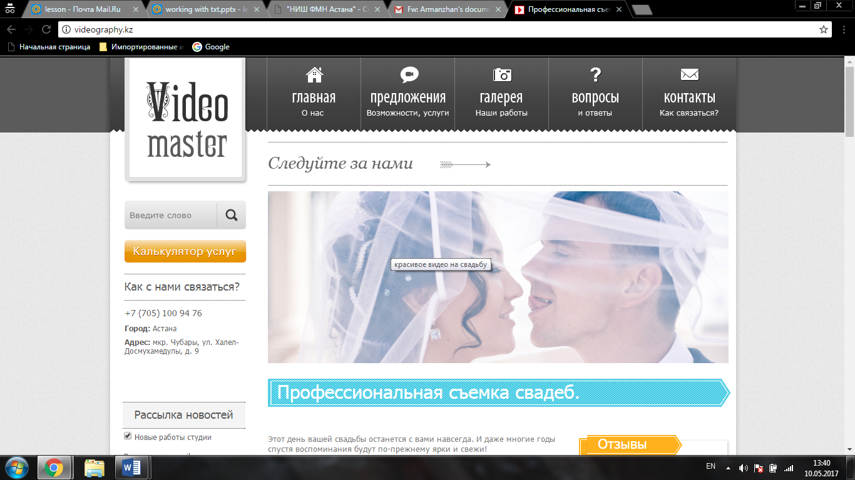

To calcuate the approximate cost of the order u can use our online calculator, choosing all the options you need

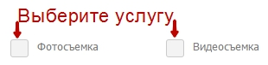

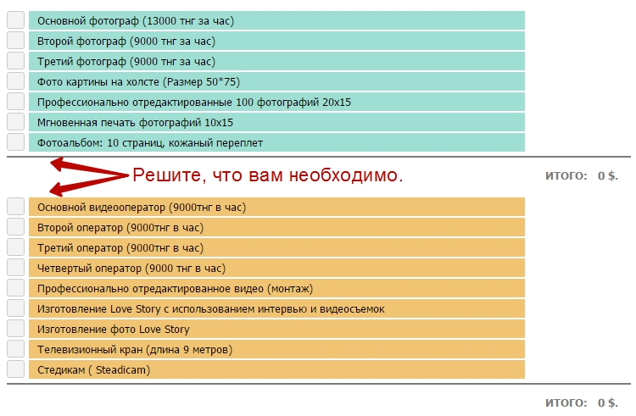

Шаг 3: Подсчет стоимости услуг

Now that you’ve gotten the primal price, you can call us, using contact window.

